Capacitive Reactance
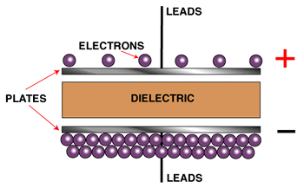A capacitor is a device that is able to store electrical energy. We talk in terms of a capacitor being "charged up," or building a "voltage potential," when current flows through the device.
A capacitor is comprised of two or more electrically conductive surfaces called "plates," insulated from each other by a material called a dielectric. Materials such as air, paper, mica and oil can be used as dielectrics.
In the very first instant that current flows, there is a surge of electrons to one plate. They are following the natural laws of attraction. Once this plate becomes saturated, the plate is fully charged.
The amount of charging a capacitor can achieve is called capacitance and is measured in Farads, or microfarads, µF. 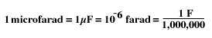
The opposition to the flow of alternating current due to capacitance is called "capacitive reactance." It is measured in ohms just like resistance and inductive reactance.
In capacitors, the current leads voltage by 90 degrees. 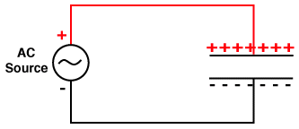
The formula for calculating the Capacitive Reactance, or impedance of a capacitor is:
Capacitive reactance, denoted as x sub c (X_{C}), is equal to the constant one million (or 106) divided by the product of 2^{p} ( or 6.28) times frequency times the capacitance . 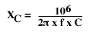
where:
X_{C} = Capacitive reactance measured in ohms.
f = is the AC frequency in Hertz.
C = is the capacitance in microfarads.
Example:
A capacitor with a capacitance of 106.1 microfarads is connected to a 120 volt, 60 hertz AC circuit. To determine the current flow in the wire, first find the capacitive reactance of the capacitor. The capacitive reactance equals 1,000,000 divided by 6.28 times 60 hertz times 106.1 microfarads which equals 25 ohms. Now use ohm's law and divide 120 volts by 25 ohms which equals 4.8 amps.
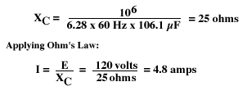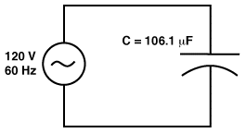
Remember the current will lead the voltage by 90 degrees so the current flow is 90 degrees ahead of the voltage sine wave.

